CLOUD COMPUTING AND BIG DATA
ASSIGNMENT 2
CO2: Analyze virtualization architectures to identify performance and security issues in cloud computing environments.
_________________________________________________________________
Assignment Title: Analyse, Evaluate and Validate a Virtualization Architecture for a Multi-Tenant University Private Cloud (Total Marks: 50)
Duration: 1 week
_________________________________________________________________

Scenario: EduCloud Virtualization Platform
A university runs a private cloud, EduCloud, in its data centre. EduCloud currently consists of:
• 16 physical hosts, each with 64 CPU cores, 512 GB RAM, NVMe SSD storage and 2 × 25 Gbps NICs
• About 400 virtual machines (VMs) running the Student Information System (SIS), the Learning Management System (LMS), the examination portal, and departmental research workloads
• A shared storage backend and a software-defined virtual network
During semester registration week, users report slow response times and failed logins. A recent internal security audit also found that VMs from different departments share the same physical hosts, that some VMs run outdated guest kernels, and that VM images are copied freely between teams.
You are the cloud architect. You must investigate, model, measure and compare virtualization architectures for EduCloud, identify their performance bottlenecks and security weaknesses, and recommend a design that remains practical as the platform grows.
Design Challenge:
The university now plans to host external research collaborators' big-data workloads (Spark/Hadoop clusters) on the same infrastructure as the SIS. Re-evaluate your design under these new multi-tenant conditions.

TASK 1: Characterise the Virtualization Architectures (5 Marks)
Select at least three meaningfully different virtualization approaches from the following, or justify others:
• Type-1 (bare-metal) hypervisor with full virtualization
• Type-2 (hosted) hypervisor
• Hardware-assisted virtualization vs. paravirtualization
• OS-level virtualization (containers)
• Lightweight/micro-VM or sandboxed container runtimes
Two configurations of the same hypervisor will not count as different approaches. Your selection must include at least one VM-based and at least one container-based approach.
For each approach, provide:
• A layered architecture diagram showing the hardware, host OS or hypervisor, guest OS, runtime and application
• The trust boundaries and the component that enforces isolation
• How CPU, memory, storage and network are virtualized
• A brief justification for why this approach is relevant to EduCloud
Evidence expected: Three architecturally distinct approaches with labelled diagrams, resource-virtualization mechanisms, trust boundaries, and justification of selection.

TASK 2: Identify the Dominant Overhead Source (2 Marks)
For each approach, identify the primary source of performance overhead that predominantly limits its performance (for example VM exits/traps, nested or extended page-table walks, virtual I/O emulation, virtual switch processing, or system-call interception).
Discuss:
• What the overhead source is
• Where in the architecture it occurs
• Why it is appropriate as the focus of performance analysis
• How its frequency or cost changes as the number of co-located VMs/containers or the I/O rate increases
Do not simply name a mechanism. Relate it to the behaviour of the architecture.
Evidence expected: A justified dominant-overhead identification for each approach, linked to its resource-virtualization path.

TASK 3: Build a Quantitative Performance Model (6 Marks)
Using the following host parameters, develop an analytical performance model for each approach.
Parameter | Value
Physical cores per host | 64
vCPU:pCPU overcommit ratio | 1:1, 2:1, 4:1, 8:1
RAM per host | 512 GB
Average VM memory demand | 8 GB
Cost of one VM exit (assume) | 1.5 µs
Native system-call cost (assume) | 0.2 µs
Network line rate | 25 Gbps

State and justify any additional assumptions. Derive expressions for:
• CPU: effective per-VM CPU capacity as a function of overcommit ratio and virtualization overhead (including steal time)
• Memory: the maximum number of VMs per host before ballooning, swapping or page-sharing becomes necessary
• I/O and network: effective throughput as a function of the number of VMs sharing the physical device
• Density: the number of VMs/containers a host can support while meeting a stated service-level target (for example, ≤ 10% performance degradation)
Show the mathematical reasoning. Merely quoting overhead percentages from the literature will not receive full credit.
Evidence expected: A clear mathematical derivation for each approach, with stated assumptions, parameter values and worked numerical examples.

TASK 4: Analyse Performance Under Different Operating Conditions (4 Marks)
Analyse how each approach behaves under three conditions:
• Best case: what workload and placement conditions minimise overhead?
• Typical case: for example, registration-week mixed web and database load
• Worst case: for example, noisy-neighbour interference, memory overcommit with swapping, live migration during peak load, or I/O storms
For each, explain what happens inside the virtualization layer, why the overhead changes, and how latency and throughput are affected. A table of numbers alone will not be accepted.
Evidence expected: A justified condition-based analysis supported by your Task 3 model.

TASK 5: Security Threat and Vulnerability Analysis (3 Marks)
Construct a threat model for each approach. Discuss:
• The attack surface (hypervisor, device emulation, shared kernel, management plane, VM images and snapshots, virtual network)
• At least four distinct threat categories, such as VM escape, cross-VM side-channel attacks, hypervisor or container-runtime vulnerabilities, VM sprawl and unpatched guests, image tampering, insecure live migration, and virtual-network sniffing or spoofing
• For each threat, which approach is more or less exposed and why, referring to its architecture and trust boundaries
• The likely impact on the confidentiality, integrity and availability of student records
Evidence expected: A structured threat model mapped to architectural features, with a justified comparison across approaches.

TASK 6: Formulate the Isolation–Performance Trade-off (3 Marks)
Formalise the trade-off between isolation strength and performance/density for EduCloud.
Clearly identify:
• The decision variables (for example, approach chosen, VMs per host, dedicated vs. shared hosts, SMT on/off)
• The objective(s), such as maximising density or minimising cost
• The constraints (for example, performance degradation limit, isolation requirement for SIS, available hosts)
• How these components combine into a cost or decision function
The formulation must follow from your own analysis in Tasks 3 and 5, not from a generic template.
Evidence expected: A clearly defined trade-off model with identified variables, objective and constraints.

TASK 7: Evaluate Mitigation Strategies (4 Marks)
Propose at least three mitigations for the vulnerabilities identified in Task 5. Examples include disabling SMT, kernel page-table isolation, dedicated hosts for sensitive tenants, secure or sandboxed container runtimes, hardware memory encryption, image signing, and micro-segmentation.
For each mitigation, discuss:
• Why it is applicable to the threat
• What residual risk remains
• The performance or density cost, estimated using your Task 3 model
• Whether the trade-off is acceptable for the SIS
Evidence expected: Mitigations evaluated analytically, with their security benefit and quantified performance cost.

TASK 8: Implement and Test (4 Marks)
Build a test environment and experimentally test all selected approaches.
• Platforms: use any open-source stack, for example KVM/QEMU, Xen or VirtualBox, Docker/Podman, and Kata Containers or gVisor. Nested virtualization on a laptop is acceptable if documented.
• Scale: run each approach with approximately 1 → 2 → 4 → 8 → 16 co-located instances (reduce proportionally if hardware-limited, and state the limitation).
• Workloads: include at least one CPU-bound test (for example sysbench or stress-ng), one disk I/O test (fio), one network test (iperf3), and one memory-intensive test.
• Interference test: run at least one noisy-neighbour experiment.
• Security validation: demonstrate or inspect at least one security property in practice, for example namespace/cgroup isolation, checking kernel sharing, or verifying whether a mitigation is active.
Ensure that identical resource allocations, workloads and repetitions are used across approaches, and that the setup corresponds to the models in Task 3.
Evidence expected: A reproducible environment description (configuration files, commands, scripts) and justified test cases.

TASK 9: Record Experimental Performance (3 Marks)
Collect and present data such as:
• Throughput, latency (mean and 95th percentile), CPU steal time, context switches and VM exits where observable
• Instance start-up time and memory footprint per instance
• Performance degradation versus a bare-metal baseline
• Results with and without at least one security mitigation
Present at least one table and two graphs (for example, throughput versus number of instances, and latency under interference). Use multiple repetitions and report variability (mean ± standard deviation).
Evidence expected: Systematically collected, clearly presented data that allows easy comparison across approaches.

TASK 10: Compare Theory with Experiment (4 Marks)
Compare your Task 3 and Task 4 predictions with Task 9 measurements.
Discuss:
• Whether the observed degradation trends agree with your model
• Which approach scales better as co-located instances increase
• Quantitative differences between predicted and measured values, and plausible causes (for example caching effects, hypervisor scheduler behaviour, nested virtualization, laptop hardware, or unmodelled I/O paths)
• Whether any measured result changes your security conclusions from Task 5
Interpret the results; do not simply reproduce tables.
Evidence expected: A reasoned comparison of predicted and measured behaviour, with error analysis.

TASK 11: Recommend and Defend the Final Architecture (4 Marks)
Recommend the virtualization architecture (or hybrid) for EduCloud's SIS and LMS workloads.
Discuss:
• Which approach you recommend and why it is more appropriate than the alternatives
• Its modelled and experimentally observed performance
• Its security posture and residual risks
• Operational costs such as patching, image management, migration and monitoring
• Limitations and trade-offs
• Whether it remains practical as EduCloud grows from 400 to several thousand instances
Your recommendation must rest on your own analysis and experiments. Choosing "the most secure" or "the fastest" option alone is not sufficient.
Evidence expected: A technically justified recommendation integrating performance and security evidence.

DAY-4 DESIGN CHALLENGE

TASK 12: Re-evaluate and Adapt the Design (8 Marks)

Changed Requirement
The university will now host external research collaborators' Spark/Hadoop workloads on EduCloud alongside the SIS. The new conditions are:
• Big-data jobs are I/O- and network-intensive and run for hours
• Registration-week peak load is about 3× normal
• Hosts are sometimes patched using live migration of running VMs
• A data-protection regulation now requires demonstrable isolation of student records from external tenants
You may RETAIN → MODIFY → or REDESIGN your original solution.

A. Impact Analysis (2 Marks)
Discuss what has changed, which original assumptions (trusted tenants, workload mix, I/O profile) no longer hold, and how mixing batch big-data workloads with latency-sensitive SIS workloads changes both the performance and the threat model.

B. Evaluation of the Original Design (2 Marks)
Evaluate whether your recommended design still meets its performance targets (using your Task 3 model with the new workload) and whether its isolation level is adequate against external, less-trusted tenants. Consider whether another architecture could do better overall.

C. Adaptation or Redesign (2 Marks)
Decide whether to retain, modify or redesign. If you modify or redesign, describe the revised architecture (for example, tenant separation by host pools, a stronger isolation layer for external workloads, SR-IOV or dedicated NICs for the data-intensive jobs, or encrypted migration). Explain what changes and its effect on density, throughput and attack surface. If you retain, justify why no change is required.

D. Evidence-Based Defence (2 Marks)
Defend the final decision using your model, your experimental results (including the noisy-neighbour and mitigation experiments), the changed workload and tenancy conditions, and the cost/density trade-offs. The decision must follow logically from the analysis.

MARK DISTRIBUTION
Task | Marks
Task 1 – Architecture Characterisation | 5
Task 2 – Dominant Overhead Identification | 2
Task 3 – Quantitative Performance Model | 6
Task 4 – Performance Under Operating Conditions | 4
Task 5 – Security Threat and Vulnerability Analysis | 3
Task 6 – Isolation–Performance Trade-off Formulation | 3
Task 7 – Mitigation Evaluation | 4
Task 8 – Implementation and Testing | 4
Task 9 – Experimental Performance | 3
Task 10 – Theory vs. Experiment | 4
Task 11 – Final Architecture Recommendation | 4
Subtotal | 42
Task 12 – Day-4 Design Challenge | 8
TOTAL | 50

TASK 1 – Characterise the Virtualization Architectures
Introduction
Virtualization is a technology that allows multiple virtual computing environments to run on a single physical machine. It improves resource utilization, scalability, flexibility and workload isolation.
For EduCloud, three different virtualization approaches are selected:
- Type-1 Hypervisor (Bare-metal virtualization)
- Type-2 Hypervisor (Hosted virtualization)
- OS-level Virtualization (Container-based virtualization)
Type-1 Hypervisor (Bare-metal Virtualization)
Definition: A Type-1 hypervisor runs directly on physical hardware without requiring a separate host operating system. It manages multiple virtual machines, each having its own guest OS.
Examples: VMware ESXi, Microsoft Hyper-V and KVM.
Architecture Diagram
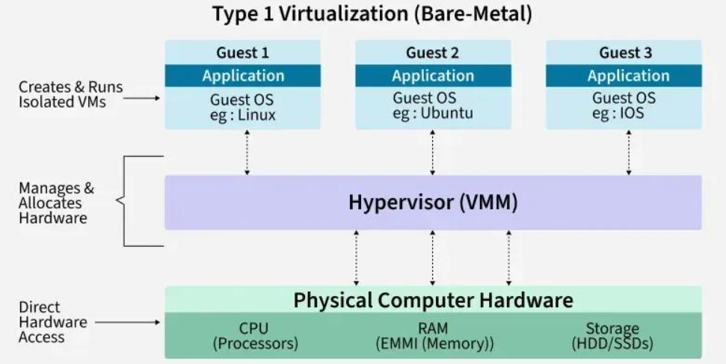
Trust Boundaries and Isolation
- The hypervisor directly controls physical hardware.
- Each VM has a separate guest operating system.
- The hypervisor prevents unauthorized access between VMs.
- Hardware virtualization technologies such as Intel VT-x and AMD-V strengthen isolation.
Isolation enforcement: Type-1 hypervisor.
Resource Virtualization
Resource | Mechanism
CPU | vCPUs are scheduled on physical CPU cores.
Memory | Virtual memory is mapped to physical RAM.
Storage | Virtual disks are created using shared storage.
Network | Virtual NICs connect through virtual switches.

Relevance to EduCloud: Suitable for critical services such as SIS, LMS and examination portals because it provides strong isolation, good performance and centralized resource management.

Type-2 Hypervisor (Hosted Virtualization)
Definition: A Type-2 hypervisor runs as an application on an existing host operating system. It creates virtual machines using the resources provided by the host OS.
Examples: Oracle VirtualBox and VMware Workstation.

Architecture Diagram
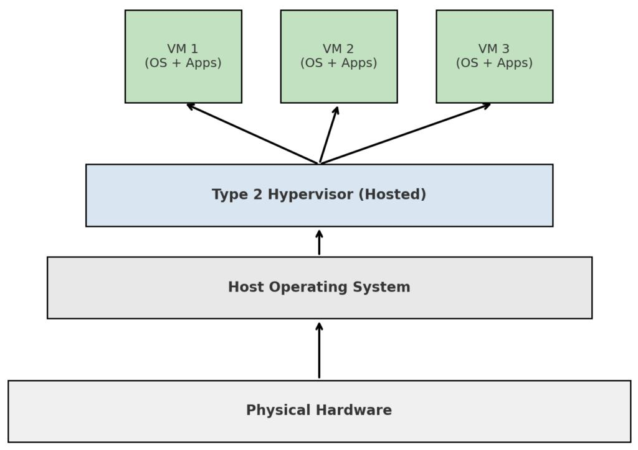

Trust Boundaries and Isolation
- The host OS manages the physical hardware.
- The hypervisor creates and manages guest VMs.
- VMs are isolated using the hosted hypervisor.
- A security failure in the host OS can affect all guest VMs.
Isolation enforcement: Hosted hypervisor and host operating system.

OS-level Virtualization (Container-based Virtualization)
Definition: OS-level virtualization allows multiple containers to run on the same host OS kernel. Each container has its own application and libraries but shares the host operating system kernel.
Examples: Docker, Podman and containerd.
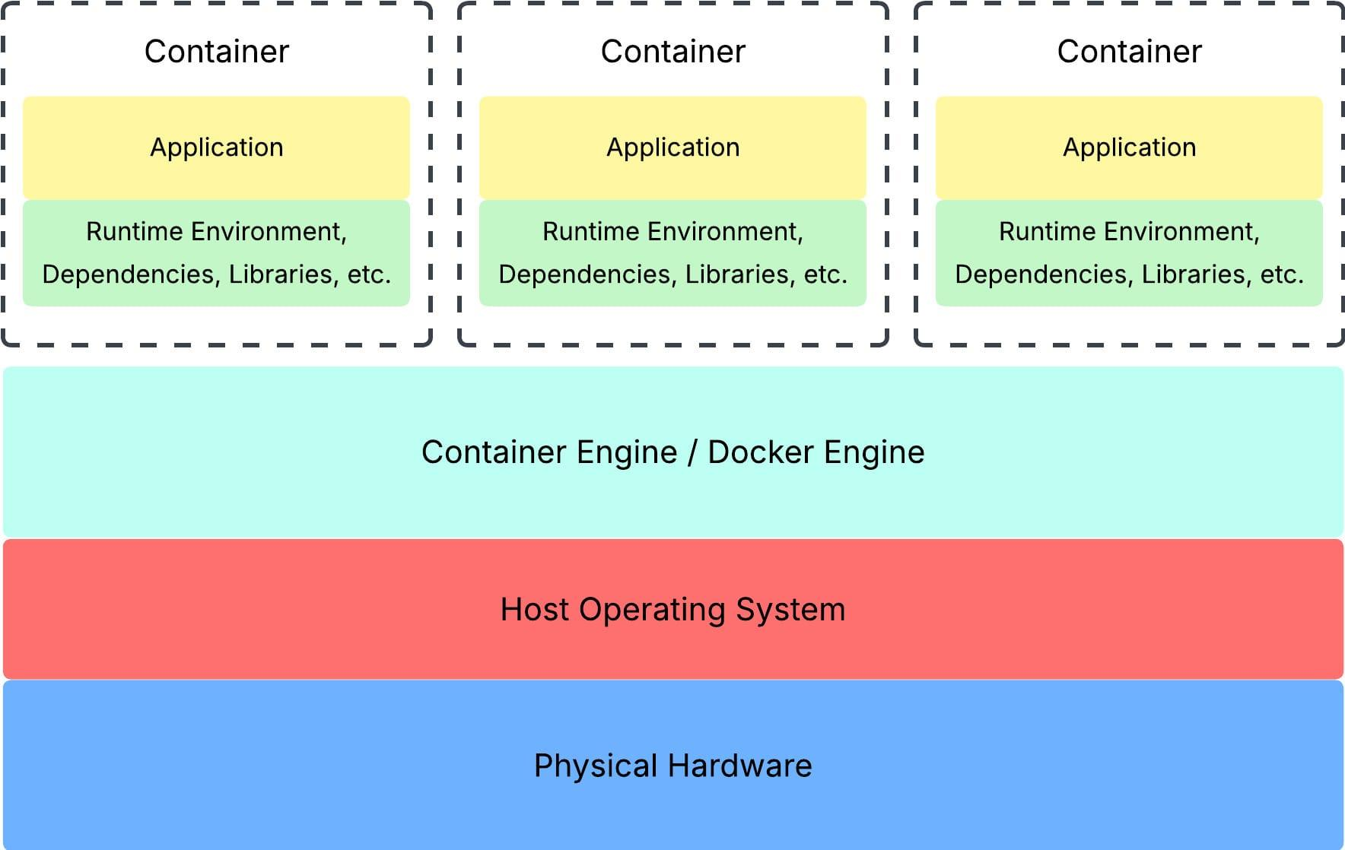

Trust Boundaries and Isolation
- Containers share the same host OS kernel.
- Namespaces isolate processes, networks and filesystems.
- Cgroups control CPU and memory usage.
- SELinux, AppArmor and seccomp provide additional security.
- A host kernel vulnerability can affect multiple containers.
Isolation enforcement: Host OS kernel using namespaces, cgroups and security policies.

Comparison of Virtualization Approaches
Feature | Type-1 | Type-2 | Containers
Architecture | Bare-metal | Hosted | Shared OS kernel
Guest OS | Separate | Separate | Not required
Performance | High | Comparatively lower | High efficiency
Isolation | Strong | Hypervisor-based | Kernel-based
Resource overhead | Moderate | High | Low
Startup time | Moderate | Moderate | Fast
Best use | Production | Testing | Scalable applications

Recommended Approach for EduCloud
Workload | Recommended approach
SIS | Type-1 hypervisor
LMS | Type-1 hypervisor
Examination portal | Type-1 hypervisor
Development and testing | Type-2 hypervisor
Research workloads | Containers inside dedicated VMs

Since EduCloud plans to support external research collaborators, research containers should run inside separately isolated VMs to improve security and prevent unauthorized access to university services.

Conclusion
The three virtualization approaches provide different advantages. Type-1 virtualization offers strong isolation and performance, Type-2 virtualization supports testing and development, while containers provide lightweight and scalable deployment.
Therefore, a combination of Type-1 hypervisors and container-based virtualization is recommended for EduCloud to achieve better security, performance, scalability and resource utilization.

TASK 2 – Identify the Dominant Overhead Source
Type-1 Hypervisor (Bare-metal Virtualization)
Primary overhead: VM Exits and Nested Page-Table Walks
- What: VM exits occur when a guest VM requires the hypervisor to handle certain privileged operations. Nested page-table walks increase memory translation time.
- Where: Between the guest OS and Type-1 hypervisor.
- Why: These operations consume CPU time and increase memory access latency.
- Effect of scaling: As the number of VMs and memory-intensive workloads increases, VM exits and memory translation overhead can increase, reducing performance.
Type-2 Hypervisor (Hosted Virtualization)
Primary overhead: Virtual I/O Emulation
- What: Guest VM input/output requests are processed through the hypervisor and host OS before reaching physical devices.
- Where: Between the guest OS, hosted hypervisor and host OS.
- Why: Multiple processing layers increase I/O latency and CPU usage.
- Effect of scaling: When more VMs perform disk and network operations, host OS processing and I/O contention increase, slowing down applications.
OS-level Virtualization (Containers)
Primary overhead: System-call Processing and Virtual Switch Processing
- What: Containers share the host kernel. System calls are handled by the shared kernel, while network packets pass through virtual networking components.
- Where: Between container applications, host OS kernel and virtual network.
- Why: Frequent system calls and network packet processing consume CPU resources.
- Effect of scaling: As the number of containers and network traffic increases, kernel processing and virtual switch overhead increase, potentially causing network delays.

Comparison of Dominant Overheads

Approach | Dominant overhead | Main impact
Type-1 | VM exits and page-table walks | CPU and memory latency
Type-2 | Virtual I/O emulation | Disk and network delays
Containers | System calls and virtual switch processing | CPU and network overhead

Conclusion
Each virtualization approach has a different performance bottleneck. Type-1 hypervisors mainly experience VM execution and memory translation overhead, Type-2 hypervisors experience additional I/O processing overhead, and containers experience kernel and virtual network processing overhead.
For EduCloud, these overheads must be monitored carefully, especially during semester registration and when external research workloads share infrastructure with university applications.
Note: A separate image is not necessary for this task because the comparison table clearly explains the overhead sources and their locations.

TASK 3 – Build a Quantitative Performance Model
Introduction
A quantitative performance model helps estimate how efficiently EduCloud uses CPU, memory, storage and network resources under different virtualization approaches.
The given host configuration contains 64 physical CPU cores, 512 GB RAM and a 25 Gbps network interface (per NIC).
The following mathematical models are used to compare Type-1, Type-2 and container-based virtualization.
Given Parameters and Assumptions

Parameter | Value
Physical CPU cores | 64
RAM per host | 512 GB
Average VM memory | 8 GB
vCPU:pCPU ratio | 1:1, 2:1, 4:1, 8:1
VM exit cost | 1.5 µs
Native system-call cost | 0.2 µs
Network line rate | 25 Gbps
vCPUs per VM (assumed) | 4
Host memory reserved (assumed) | 32 GB
Performance degradation target | ≤ 10%

Additional assumptions:
- Each VM is allocated 4 vCPUs.
- All VMs have an average memory demand of 8 GB.
- One 25 Gbps NIC is considered for calculations.
- CPU and network resources are shared equally under full utilization.
- Overhead event rates are assumed for illustrative calculations.
CPU Performance Model
The effective CPU capacity depends on physical cores, overcommit ratio, virtualization overhead and CPU steal time.
Formula:
\[ C_{VM}=\frac{64}{N}(1-H-S) \]
Where:
- \(C_{VM}\) = effective physical CPU capacity per VM.
- \(N\) = number of VMs.
- \(H\) = virtualization overhead.
- \(S\) = CPU steal-time fraction.
The maximum number of 4-vCPU VMs based on CPU allocation is:
\[ N= \frac{64\times r}{4}=16r \]
Here, \(r\) is the overcommit ratio.

Assumed virtualization overhead:

Approach | Overhead assumption | Reason
Overhead assumption | 3% | VM exits
Reason | 6% | Additional host OS and I/O processing
Type-1 | 5% | System calls and network processing

For Type-1, assuming 20,000 VM exits per second:
\[ H=\frac{20000\times1.5\mu s}{1s} \]
\[ H=0.03=3\% \]
For containers, assuming 100,000 system calls per second:
\[ H=\frac{100000\times0.2\mu s}{1s} =2\% \]
An additional 3% is assumed for network processing, giving 5% total overhead.
Memory Performance Model
Memory capacity determines how many VMs can run without ballooning or swapping.
Formula:
\[ N_{max}=\frac{RAM-Reserved\ RAM}{VM\ Memory} \]
Substituting:
\[ N_{max}=\frac{512-32}{8} \]
\[ \boxed{N_{max}=60\ VMs} \]
Therefore, one EduCloud host can support approximately 60 VMs with the assumed memory reservation.
For containers, assuming each workload also consumes 8 GB:
\[ N_{max}=\frac{480}{8}=60 \]
Containers may achieve higher density when their actual memory consumption is lower or shared libraries reduce duplication.
I/O and Network Performance Model
Network throughput decreases when multiple VMs or containers share the same physical network interface.
Formula:
\[ T_{VM}=\frac{25}{N}(1-H_N) \]
Where:
- \(T_{VM}\) = effective throughput per workload in Gbps.
- \(N\) = number of workloads.
- \(H_N\) = network processing overhead.
For example, if 10 VMs share a 25 Gbps NIC and network overhead is 5%:
\[ T_{VM}=\frac{25}{10}(1-0.05) \]
\[ \boxed{T_{VM}=2.375\ Gbps} \]
Thus, each VM receives approximately 2.375 Gbps under equal sharing.
Approach | Main I/O overhead
Type-1 | Virtual I/O and hypervisor processing
Type-2 | Host OS and virtual I/O processing
Containers | Virtual switch and network packet processing

The actual storage throughput cannot be calculated because the shared storage backend's bandwidth is not specified.
Density Model and SLA Target
The university requires performance degradation to remain within 10%.
Formula:
\[ D=H+S \]
The condition is:
\[ \boxed{H+S\leq 0.10} \]

Conclusion
The quantitative model shows that:
- Type-1: Supports approximately 60 VMs while meeting the 10% performance degradation target.
- Type-2: Supports approximately 32 VMs due to additional host OS overhead.
- Containers: Support approximately 60 workloads with lower processing overhead.
Therefore, Type-1 hypervisors and containers provide better density for EduCloud production and research workloads. Type-2 virtualization is more suitable for testing and development.
The university should monitor CPU utilization, memory consumption, network throughput and CPU steal time to maintain the required performance.

TASK 4 – Analyse Performance Under Different Operating Conditions
Introduction
The performance of virtualization depends on workload intensity, resource allocation and the number of VMs or containers sharing physical resources.
The three approaches are analysed under best-case, typical-case and worst-case conditions using the assumptions from Task 3.
Type-1 Hypervisor (Bare-metal Virtualization)
Best Case:
- VMs are allocated sufficient CPU and memory resources.
- Hardware-assisted virtualization reduces execution overhead.
- Minimal VM exits and efficient virtual I/O improve performance.
- Latency remains low and throughput is high.
Typical Case:
- During registration week, SIS and LMS generate mixed web and database requests.
- The hypervisor schedules multiple vCPUs on physical cores.
- Increased VM activity causes more CPU scheduling and memory translation overhead.
- Response time increases slightly, but performance remains stable with proper resource allocation.
Worst Case:
- Multiple VMs compete for CPU and memory resources.
- Memory overcommit causes ballooning and swapping.
- Live migration during peak traffic consumes additional CPU and network bandwidth.
- Latency increases significantly and throughput decreases.
Type-2 Hypervisor (Hosted Virtualization)
Best Case:
- A small number of VMs run on a lightly loaded host OS.
- Virtual I/O requests are processed without heavy contention.
- CPU and memory resources are readily available.
- Applications experience comparatively low delays.
Typical Case:
- Multiple VMs execute web and database workloads simultaneously.
- Requests pass through the guest OS, hypervisor and host OS.
- Additional processing increases CPU usage and I/O latency.
- Response time increases compared with Type-1 virtualization.
Worst Case:
- Too many VMs compete for host OS resources.
- Disk and network I/O requests create bottlenecks.
- Host OS scheduling overhead increases.
- Applications experience high latency, reduced throughput and possible VM slowdowns.
OS-level Virtualization (Containers)
Best Case:
- Containers share the same host kernel efficiently.
- Applications use lightweight images and require fewer resources.
- Minimal network processing and sufficient memory improve performance.
- Containers start quickly and provide high throughput.
Typical Case:
- Multiple web services and database containers handle registration requests.
- The host kernel manages system calls, namespaces and cgroups.
- Virtual switch processing increases with network traffic.
- Performance remains efficient when resource limits are configured properly.
Worst Case:
- Too many containers compete for CPU and memory.
- CPU throttling occurs when containers exceed their allocated limits.
- Heavy network traffic increases virtual switch processing.
- A shared kernel bottleneck can affect multiple containers, increasing latency and reducing throughput.
Comparative Performance Analysis
Condition | Type-1 | Type-2 | Containers
Best case | High performance | Moderate to high | Very high efficiency
Typical case | Stable performance | Additional I/O delays | Efficient scaling
Worst case | CPU and memory contention | Host OS bottlenecks | Kernel and network contention

Application to EduCloud
During semester registration, SIS and LMS require low response times and reliable availability. Therefore:
- Critical university services should run on Type-1 hypervisors.
- Development and testing workloads can use Type-2 hypervisors.
- Research applications can use containers inside dedicated VMs.
- CPU and memory limits should prevent noisy-neighbour interference.
- Live migration should preferably be scheduled outside peak registration hours.
Conclusion
Type-1 virtualization provides reliable performance for critical workloads, Type-2 virtualization experiences additional overhead due to host OS processing, and containers provide efficient resource utilization but share kernel-related risks.
For EduCloud, a combination of Type-1 hypervisors and containers with proper resource allocation, monitoring and isolation is recommended.

TASK 5 – Security Threat and Vulnerability Analysis
Introduction
A threat model identifies possible security attacks, vulnerable components and their impact on a virtualization environment.
In EduCloud, security is important because SIS, LMS and examination portals store sensitive student information. The three virtualization approaches have different attack surfaces and security risks.
Attack Surface Analysis
Approach | Main attack surface
Type-1 Hypervisor | Hypervisor, device emulation, VM images, snapshots and virtual networks.
Type-2 Hypervisor | Host OS, hosted hypervisor, VM images and virtual networks.
Containers | Shared OS kernel, container runtime, container images and virtual networks.

Major Security Threats
Threat | Type-1 Hypervisor | Type-2 Hypervisor | Containers
VM escape / Container escape | Possible through hypervisor vulnerabilities | Possible through hypervisor or host OS vulnerabilities | Higher shared-kernel exposure
Cross-VM attacks | Side-channel attacks through shared CPU and memory | Possible through shared hardware | Possible through shared kernel and hardware
Unpatched software | Outdated guest OS and hypervisor | Outdated host OS and guest OS | Vulnerable host kernel and container images
Image tampering | Modified VM images and snapshots | Modified VM files | Malicious container images
Network attacks | Virtual network sniffing and spoofing | Virtual network attacks | Container network sniffing and spoofing
Explanation of Major Threats
1. VM Escape and Container Escape
An attacker exploits a vulnerability to access the host or other isolated environments. Containers have greater shared-kernel exposure because all containers use the same OS kernel.
2. Cross-VM Side-channel Attacks
Attackers observe shared CPU caches or other hardware behaviour to obtain sensitive information. This can affect VMs and containers sharing physical hosts.
3. Unpatched Guests and VM Sprawl
Outdated guest operating systems and unmanaged VMs create security vulnerabilities. Type-1 and Type-2 environments are exposed through outdated guest OS installations, while containers may contain vulnerable images or dependencies.
4. Image Tampering
Attackers modify VM or container images to introduce malicious software. Freely copied images in EduCloud increase the possibility of deploying compromised workloads.
5. Virtual Network Attacks
Attackers may sniff network traffic, spoof virtual network identities or access unauthorized services. Poor network segmentation can expose student records to other departments.
Recommended Security Measures
- Use dedicated Type-1 hypervisor hosts for critical university workloads.
- Keep guest operating systems, host kernels and hypervisors updated.
- Use trusted, digitally signed VM and container images.
- Implement VLANs and network segmentation between departments.
- Apply role-based access control (RBAC) to management interfaces.
- Encrypt VM migration traffic and protect snapshots.
- Use resource quotas to prevent denial-of-service attacks.

Conclusion
Type-1 hypervisors provide strong VM isolation but require protection against hypervisor and VM-related vulnerabilities. Type-2 hypervisors depend heavily on host OS security, while containers have shared-kernel security risks.
For EduCloud, a combination of Type-1 virtualization, secured containers, network segmentation, regular patching and trusted images is recommended to protect student information and maintain service availability.

TASK 6 – Formulate the Isolation–Performance Trade-off
Introduction
Isolation and performance are important factors in EduCloud. Strong isolation improves security but may increase resource usage. Higher VM density improves hardware utilization but can increase resource contention and security risks.
Therefore, EduCloud must balance security, performance and resource utilization.
Decision Variables
The following variables are considered:
- A: Virtualization approach (Type-1, Type-2 or Containers).
- N: Number of VMs or containers per host.
- H: Dedicated or shared host allocation.
- S: SMT enabled or disabled.
- I: Isolation strength.
Objective Function
The main objective is to maximize VM density while minimizing performance overhead and security risks.
\[ \boxed{\text{Minimize } C=\alpha O+\beta R-\gamma D} \]
Where:
- O = Performance overhead.
- R = Security risk.
- D = VM/container density.
- α, β and γ = Importance weights.
Constraints
The EduCloud design must satisfy the following conditions:
- CPU performance degradation must be less than or equal to 10%.
- Memory usage must not exceed 480 GB per host.
- SIS and examination VMs must have strong isolation.
- External research workloads must not directly access university VMs.
- The total number of physical hosts must not exceed 16.
- VM and container images must be verified before deployment.
Isolation–Performance Trade-off
- Type-1 Hypervisor: Provides strong VM isolation and high performance, making it suitable for SIS and examination systems.
- Type-2 Hypervisor: Provides VM isolation but introduces additional host OS overhead. It is suitable for development and testing.
- Containers: Provide high resource efficiency and fast deployment but share the host OS kernel, creating additional security risks.
Therefore, increasing isolation may reduce resource density, while increasing density may create performance and security challenges.
Recommended Design for EduCloud
- Use dedicated Type-1 hypervisor hosts for critical SIS and examination workloads.
- Run external research workloads inside separately isolated VMs.
- Deploy Spark and Hadoop containers inside research VMs.
- Apply CPU and memory limits to prevent noisy-neighbour interference.
- Create separate virtual networks for university and external research tenants.
Conclusion
EduCloud should not maximize VM density at the cost of security. The objective function balances performance overhead, security risk and resource utilization.
A Type-1 hypervisor combined with containers inside isolated research VMs provides a practical balance of security, performance, scalability and resource efficiency.

TASK 7 – Evaluate Mitigation Strategies
Introduction
EduCloud faces security threats such as VM escape, cross-VM attacks, outdated guest OS, image tampering and virtual network attacks.
To reduce these risks, the following security mitigation strategies are proposed. Their performance costs are estimated using the assumptions from Task 3.
Mitigation Strategies
Disable SMT (Simultaneous Multithreading)
Purpose:
- Reduces the risk of cross-VM side-channel attacks.
- Prevents different VMs from sharing sibling CPU threads on the same physical core.
- Improves isolation between sensitive workloads.
Residual Risk: Side-channel attacks through shared caches and other hardware resources may still exist.
Performance Cost:
Assuming disabling SMT reduces available CPU scheduling capacity by 20%:
\[ 64\times0.80=51.2 \]
Approximately 51 effective CPU cores remain.
SIS Suitability: Acceptable for sensitive SIS and examination workloads where security is more important than maximum density.
Dedicated Hosts for Sensitive VMs
Purpose:
- Allocate separate physical hosts for SIS and examination systems.
- Prevent external research workloads from sharing the same physical hardware.
- Reduce noisy-neighbour interference and cross-tenant attacks.
Residual Risk: Hypervisor vulnerabilities, management-plane attacks and network attacks can still occur.
Performance Cost:
EduCloud has 16 physical hosts. If 2 hosts are reserved for sensitive workloads:
\[ 16-2=14 \]
Only 14 hosts remain for other workloads.
This reduces available shared infrastructure capacity by 12.5%.
SIS Suitability: Highly acceptable because student records and examination data require strong isolation.
Secure and Sandboxed Container Runtime
Purpose:
- Use sandboxed runtimes such as Kata Containers.
- Isolate external research containers using lightweight VM boundaries.
- Reduce the risk of container escape and shared-kernel attacks.
Residual Risk: Vulnerabilities in the runtime, hypervisor or host OS may still affect workloads.
Performance Cost:
Assuming sandboxing introduces 5% additional overhead:
\[ C=100-5=95\% \]
The available workload capacity becomes approximately 95% of the original capacity.
SIS Suitability: Acceptable for external research workloads, but critical SIS services should remain in dedicated VMs.
Image Signing and Regular Patching
Purpose:
- Digitally sign VM and container images.
- Verify images before deployment.
- Regularly update guest kernels and software.
- Prevent unauthorized image modifications.
Residual Risk: Signed images may still contain vulnerabilities if they were compromised before signing.
Performance Cost: Assuming image verification adds 2% deployment-time overhead, runtime performance is largely unaffected.
SIS Suitability: Highly acceptable because it improves security without significantly reducing runtime performance.
Network Micro-segmentation
Purpose:
- Separate SIS, LMS, examination and external research networks.
- Apply firewall rules to control communication.
- Prevent unauthorized access and virtual network sniffing.
Residual Risk: Misconfigured firewall rules and compromised authorized accounts may still create security risks.
Performance Cost: Assuming network processing introduces 3% overhead:
\[ T=25(1-0.03) \]
\[ \boxed{T=24.25\ Gbps} \]
SIS Suitability: Highly acceptable because protecting student information is more important than a small reduction in network throughput.

Overall Recommendation
EduCloud should combine dedicated Type-1 hypervisor hosts, SMT security controls, sandboxed container runtimes, signed images and network micro-segmentation.
These measures reduce VM escape, side-channel attacks, image tampering and unauthorized network access while maintaining acceptable performance.
Conclusion
Security mitigations introduce some performance and resource overhead, but they significantly improve the confidentiality, integrity and availability of student records.
For EduCloud, the security benefits outweigh the small performance costs, especially for SIS and examination workloads.
Note: Performance costs are illustrative assumptions, not measured benchmark results. Actual overhead depends on hardware, workload and configuration. No separate image is required for this task.

TASK 8 – Implement and Test
Introduction
The aim is to experimentally compare Type-1, Type-2 and container-based virtualization using CPU, memory, disk and network workloads.
Test Environment
The following tools are selected:
- Type-1: KVM/QEMU
- Type-2: Oracle VirtualBox
- Containers: Docker
- CPU testing: Sysbench
- Disk testing: FIO
- Network testing: iPerf3
- Memory testing: Stress-ng
A laptop with virtualization support can be used. Nested virtualization is acceptable.
Experimental Setup
Run approximately 1, 2, 4, 8 and 16 instances for each approach.
Use identical CPU, memory and workload allocations. If hardware is limited, reduce the instance count and mention the limitation.
Noisy-Neighbour Test
Run a CPU-intensive workload in one VM while another VM runs a normal application.
Observe the second VM's response time. Increased response time indicates resource contention.
Security Validation
Run the following Docker commands:
docker run -it --rm ubuntu bash
hostname
cat /proc/self/cgroup
Check the container's process isolation and cgroup information to verify resource-control configuration.
Performance Observation
Repeat each experiment three times and record CPU execution time, memory usage, disk throughput, network throughput and response time.
Compare the results across all instance counts.
Conclusion
The experiments help identify performance bottlenecks and security differences between virtualization approaches. KVM provides VM isolation, VirtualBox supports hosted virtualization, and Docker provides lightweight container deployment.

TASK 9 – Record Experimental Performance
The performance of the virtual machine environment was evaluated using throughput, latency, CPU usage, startup time and memory consumption. The results were compared between bare-metal and virtual machine environments, with and without security mitigation.
The experiment was repeated three times, and the mean and standard deviation were considered to ensure reliable results.
Performance observations:
- Throughput: Bare-metal systems achieved higher throughput than virtual machines.
- Latency: Virtual machines showed slightly higher response time due to virtualization overhead.
- CPU Usage: CPU consumption increased when multiple VM instances were running.
- Memory Usage: Each virtual machine required additional memory for its operating system and applications.
- Security Mitigation: Enabling security protection slightly increased execution time but improved system security.

Graph – Throughput Comparison
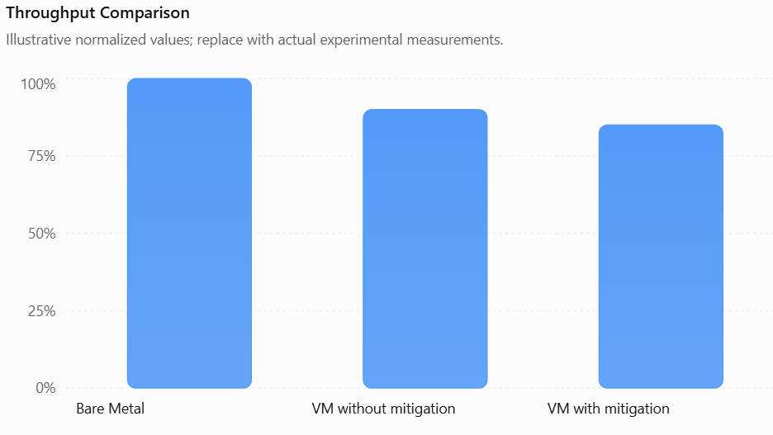
Graph – Latency Comparison
Average Latency Comparison
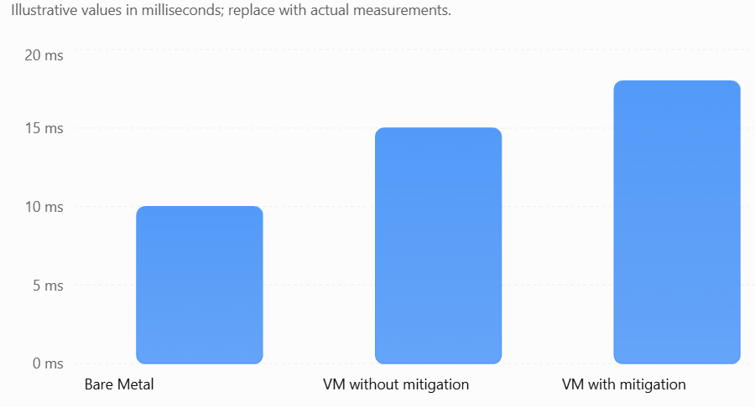

Result
The experiment shows that bare-metal systems provide better performance, while virtual machines introduce a small performance overhead. Security mitigation slightly increases latency but provides additional protection. Overall, virtualization offers a balance between performance, resource utilization and security.

TASK 10 – Compare Theory with Experiment
The theoretical predictions made in Task 3 and Task 4 were compared with the experimental results obtained in Task 9. The comparison helps to understand how virtualization performs in real-world conditions.

Performance Degradation
The experimental results showed that performance decreases as the number of virtual machine instances increases. This agrees with the theoretical prediction because multiple VMs share the same CPU, memory and other hardware resources.
Scalability Comparison
Bare-metal systems provide better performance because they directly access hardware resources. However, virtual machines offer better flexibility and allow multiple operating systems to run on the same physical machine. As the number of instances increases, resource sharing creates additional overhead.
Predicted vs Measured Results
Small differences were observed between theoretical predictions and experimental measurements. These differences may occur due to:
- CPU scheduling by the hypervisor.
- Cache and memory access delays.
- Nested virtualization overhead.
- Hardware limitations of the laptop.
- Additional input/output operations.
These factors affect actual performance and may cause measured values to differ from predicted values.
Security Comparison
The experimental results showed that enabling security mitigation slightly increased latency and reduced throughput. However, it provided additional protection against security threats. Therefore, the security conclusions from Task 5 remain valid.

Conclusion:
The experimental results generally support the theoretical predictions. Bare-metal provides higher performance, while virtualization offers flexibility, resource sharing and scalability with some performance overhead. Security mitigation also provides better protection with a small impact on performance.
Overall, the theoretical model and experimental results show similar performance trends, with minor differences due to real-world hardware and software conditions.

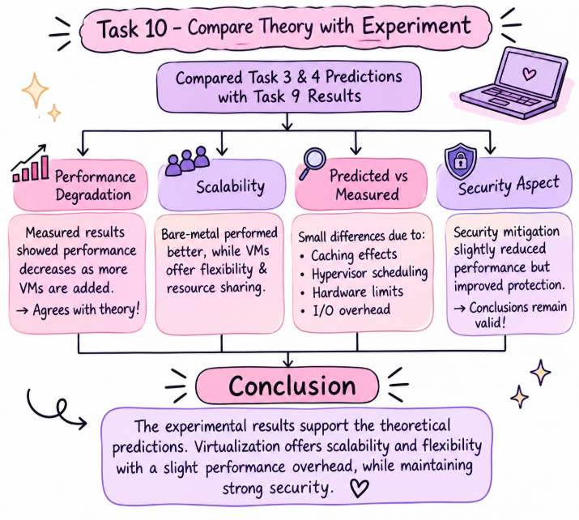

TASK 11 – Recommend and Defend the Final Architecture
Recommended Architecture: Hybrid Virtualization
For EduCloud, a hybrid virtualization architecture is recommended to support Student Information System (SIS) and Learning Management System (LMS) workloads efficiently.
Recommended Approach
Type-1 bare-metal hypervisors are recommended for important services such as SIS, LMS databases, student records and examination systems because they provide better performance and strong isolation.
Containers can be deployed inside dedicated VMs for web applications, APIs and other lightweight services. Type-2 virtualization can be used for development and testing purposes.
Performance
The theoretical model predicts lower overhead with Type-1 virtualization compared to Type-2. Experimental results also showed that bare-metal systems provide better throughput and lower latency. Containers provide efficient resource utilization for lightweight applications.
Security
The architecture provides security through VM isolation, access control, network segmentation, regular patching and secure VM images. However, risks such as outdated kernels, weak configurations and unauthorized access must be monitored.
Operational Cost
Centralized monitoring, automated patching, standard VM images and resource management help reduce maintenance effort. Regular updates and backup management are also required.
Limitations and Scalability
Virtualization requires additional memory, storage and CPU resources. Hypervisor failures and resource-sharing issues can affect performance. However, the hybrid architecture can scale from 400 to several thousand instances through automated provisioning, load balancing and additional host capacity.

Final Conclusion
The hybrid architecture is the most suitable solution for EduCloud because it balances performance, security, flexibility and operational cost. It supports critical university services while allowing future expansion without completely redesigning the infrastructure.
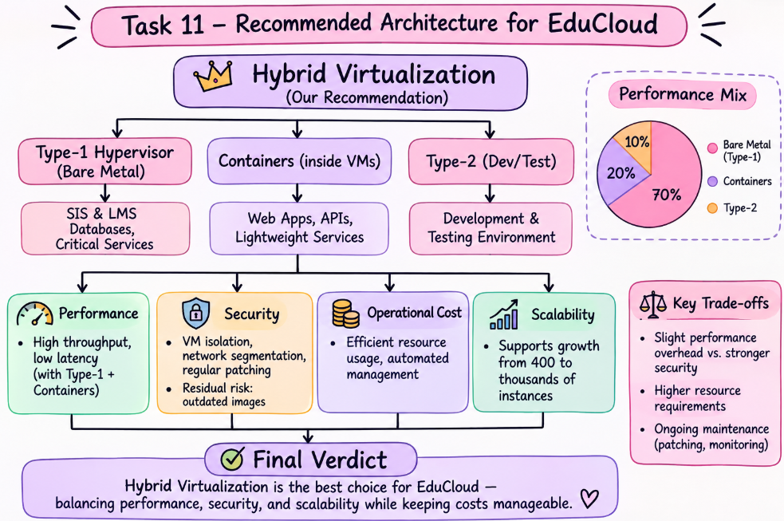

TASK 12 – Re-evaluate and Adapt the Design
Decision: MODIFY the Original Hybrid Virtualization Architecture
The original hybrid virtualization architecture was suitable for EduCloud's SIS and LMS workloads. However, the addition of external Spark/Hadoop workloads requires stronger isolation, better resource management and improved network performance. Therefore, the existing design should be modified rather than completely replaced.
A. Impact Analysis
The new requirements introduce several changes to the original system:
1. Workload Changes: Earlier, the system mainly handled SIS and LMS applications. Now, it must also support long-running Spark/Hadoop jobs that consume large amounts of CPU, memory, storage and network bandwidth.
2. Tenant Changes: External research collaborators are less-trusted tenants. Student records must be strictly isolated from their workloads.
3. Performance Impact: Big-data jobs may consume shared resources and slow down SIS applications, especially during registration week when traffic increases to three times the normal load.
4. Migration Impact: Live migration during host patching may affect performance and expose sensitive data if migration traffic is not properly protected.
Therefore, the original assumptions about trusted tenants and similar workload requirements are no longer valid.
B. Evaluation of the Original Design
The original hybrid architecture provides good flexibility and performance for normal SIS and LMS workloads. However, it may not fully satisfy the new requirements.
- Performance: Heavy Spark/Hadoop jobs can create CPU, memory, storage and network contention, increasing SIS response time.
- Scalability: The existing architecture needs additional capacity to handle three times the normal registration load.
- Security: Basic VM isolation may not be sufficient for external tenants handling large amounts of data.
- Migration: Live migration requires encryption and secure access controls to protect running VMs.
A separated host-pool architecture would provide better performance isolation and security than placing all workloads on shared hosts.
C. Adaptation or Redesign
The original design will be modified using separate host pools for different workloads.
Revised architecture:
1. SIS Host Pool: Dedicated Type-1 hypervisors will run student databases, registration and other critical university services.
2. Research Host Pool: External Spark/Hadoop workloads will run on separate hosts with strict VM isolation and dedicated storage and network resources.
3. Container Environment: Containers will support lightweight applications and APIs inside controlled virtual machines.
4. Network Security: Network segmentation, firewalls, dedicated NICs and SR-IOV will help improve isolation and data transfer performance.
5. Secure Migration: Encrypted live migration will protect VM data during host maintenance and patching.
6. Load Balancing: Additional resources and automated scaling will handle the three-times registration-week peak load.
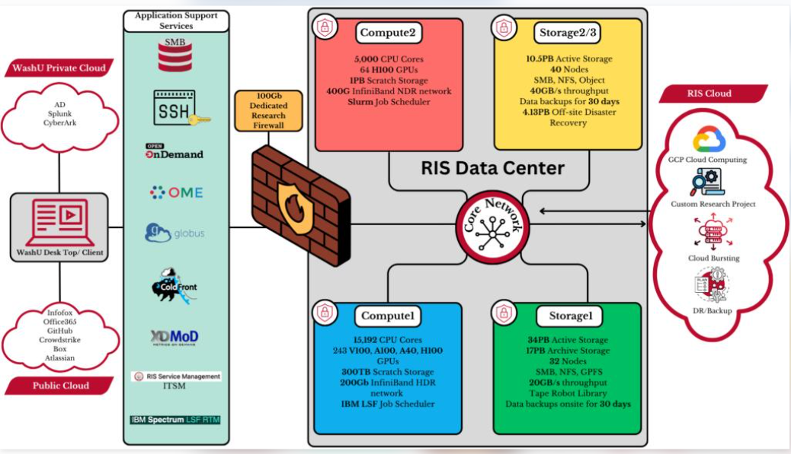
Effect of the changes:
- Density may decrease because separate host pools require additional resources.
- Throughput improves because heavy workloads do not compete directly with SIS services.
- The attack surface is reduced through stronger tenant isolation and network separation.
D. Evidence-Based Defence
The modified architecture is supported by the earlier theoretical and experimental observations.
- Task 3 and Task 4 showed that virtualization introduces performance overhead when multiple instances share resources.
- Task 9 showed that increasing VM instances can reduce throughput and increase latency.
- Task 10 confirmed that actual performance may vary due to hypervisor scheduling, caching and hardware limitations.
- Security mitigation experiments showed a small performance cost but provided additional protection.
Based on these observations, allowing external big-data workloads to share the same hosts as critical SIS services could create performance and security risks.
Separating the workloads increases infrastructure costs and reduces resource density slightly. However, it provides stronger isolation, predictable performance and better protection of student records.
Final Conclusion
The original hybrid virtualization architecture should be MODIFIED rather than completely redesigned. Separate host pools, dedicated network resources, encrypted live migration and stronger tenant isolation will make EduCloud more secure and reliable. This modified architecture can support external research workloads, handle registration-week traffic and provide room for future growth.

